FWC IITH INTERNSHIP
DIGITAL – DESIGN
DIGITAL – DESIGN:
Question:
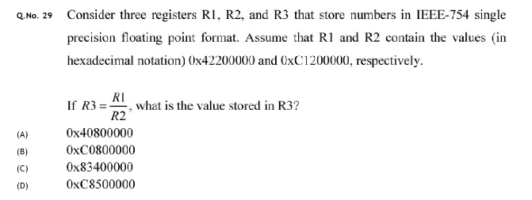
ANSWER: (B) 0xC0800000
Detailed Solution :
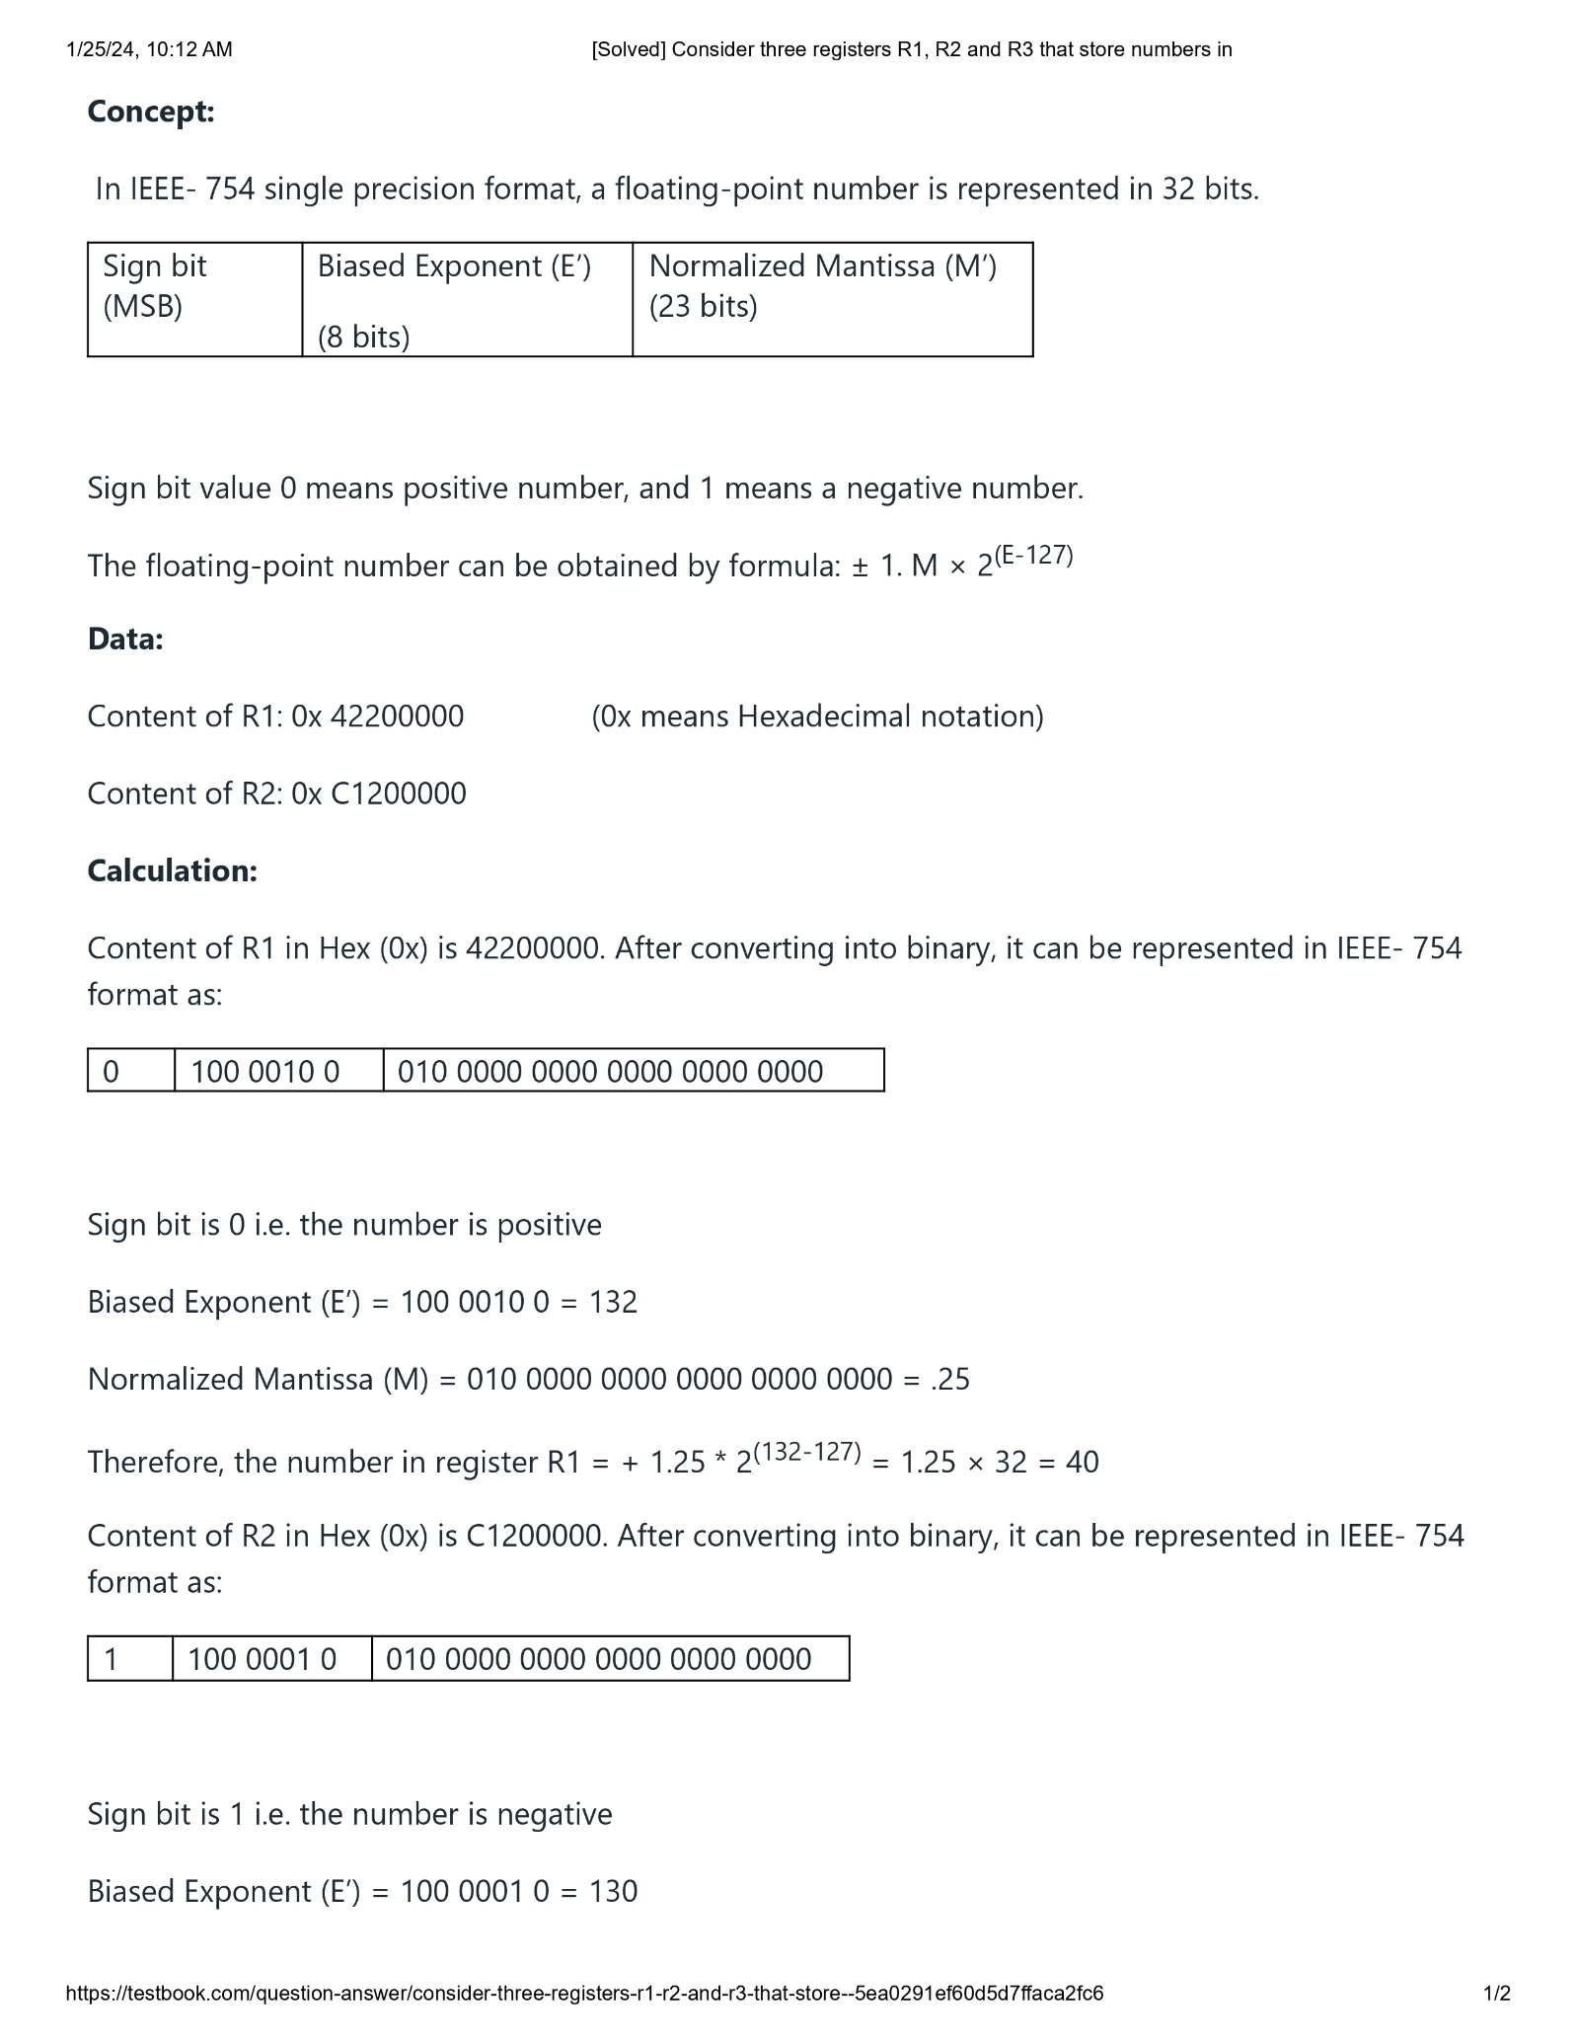

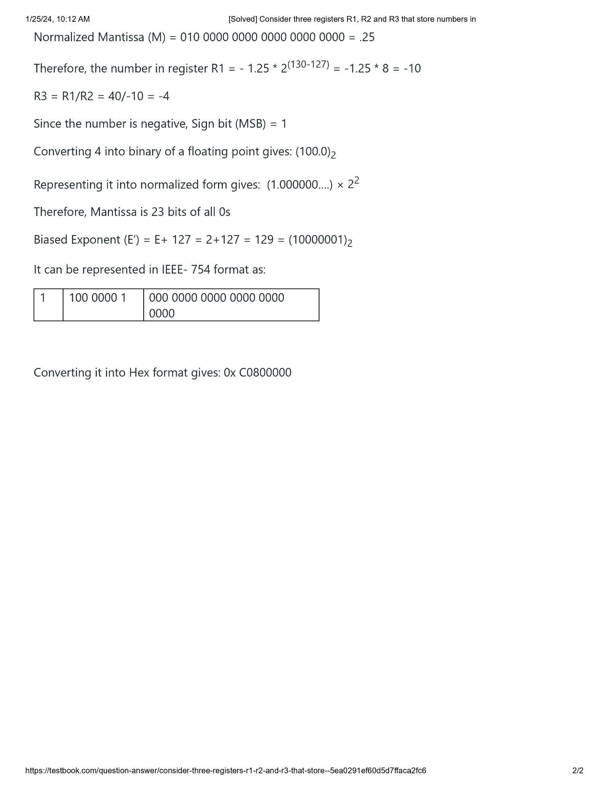
CODE:
#include <LiquidCrystal.h>

// Initialize the library with the numbers of the interface pins
LiquidCrystal lcd(12, 11, 5, 4, 3, 2);

void setup() {
// Set up the LCD's number of columns and rows:
lcd.begin(16, 2);

// IEEE-754 single precision floating-point format values for R1 and R2 in hexadecimal
uint32_t R1_hex = 0x42200000;
uint32_t R2_hex = 0xC1200000;

// Interpret R1 and R2 as floats
float R1 = (float)&R1_hex;
float R2 = (float)&R2_hex;

// Calculate R3 as per the given formula
float R3 = R1 / R2;

// Convert float to hex
uint32_t R3_hex = (uint32_t)&R3;

// Print results to LCD
lcd.print("R1: ");
lcd.print("0x42200000");
lcd.setCursor(0, 1);
lcd.print("R2: ");
lcd.print("0xC1200000");
delay(2000);

lcd.clear();
lcd.print("R3: ");
lcd.print("0x");
lcd.print(R3_hex, HEX);
}

void loop() {
}

EXPLANATION:
This code uses the LiquidCrystal library to display information on an LCD screen. Let's break down the code line by line:

1. ```cpp
#include <LiquidCrystal.h>
```
This line includes the LiquidCrystal library, which is used for controlling LCD displays.

2. ```cpp
// Initialize the library with the numbers of the interface pins
LiquidCrystal lcd(12, 11, 5, 4, 3, 2);
```
This line initializes the `LiquidCrystal` object named `lcd` with the pin numbers for the interface to the LCD. The parameters represent (in order): RS (Register Select), E (Enable), D4, D5, D6, and D7.

3. ```cpp
void setup() {
```
The `setup` function is a standard Arduino function that runs once when the Arduino is powered up or reset.

4. ```cpp
// Set up the LCD's number of columns and rows:
lcd.begin(16, 2);
```
This line initializes the LCD with 16 columns and 2 rows.

5. ```cpp
// IEEE-754 single precision floating-point format values for R1 and R2 in hexadecimal
uint32_t R1_hex = 0x42200000;
uint32_t R2_hex = 0xC1200000;
```
These lines define two variables `R1_hex` and `R2_hex` with hexadecimal values representing IEEE-754 single precision floating-point format. These values are essentially the binary representation of floating-point numbers.

6. ```cpp
// Interpret R1 and R2 as floats
float R1 = (float)&R1_hex;
float R2 = (float)&R2_hex;
```
These lines reinterpret the bit patterns in `R1_hex` and `R2_hex` as floating-point numbers and store them in `R1` and `R2`.

7. ```cpp
// Calculate R3 as per the given formula
float R3 = R1 / R2;
```
This line calculates the value of `R3` by dividing `R1` by `R2`.

8. ```cpp
// Convert float to hex
uint32_t R3_hex = (uint32_t)&R3;
```
This line reinterprets the bit pattern of the float `R3` as an unsigned integer, essentially obtaining the hexadecimal representation of the floating-point number.

9. ```cpp
// Print results to LCD
lcd.print("R1: ");
lcd.print("0x42200000");
lcd.setCursor(0, 1);
lcd.print("R2: ");
lcd.print("0xC1200000");
delay(2000);
```
These lines print the initial values of `R1` and `R2` (in hexadecimal format) to the LCD, with a delay of 2000 milliseconds (2 seconds).

10. ```cpp
lcd.clear();
lcd.print("R3: ");
lcd.print("0x");
lcd.print(R3_hex, HEX);
```
After a delay, this part of the code clears the LCD, then prints the result `R3` (in hexadecimal format) to the LCD.

11. ```cpp
void loop() {
```
The `loop` function is another standard Arduino function. In this case, it's empty, meaning it doesn't contain any code. This function repeats indefinitely after the `setup` function has run once.
The primary purpose of this code is to demonstrate converting and performing operations on IEEE-754 floating-point values and displaying the results on an LCD screen.
CIRCUIT CONNECTIONS:
Hello, this is Bing. I can help you with your Arduino project. 😊
Based on the image you sent, you have a JHD162A LCD display that can show 16 characters in 2 rows. You need to connect it to an Arduino Uno and a breadboard as follows:
- Connect pin 12 on the Arduino to pin RS on the LCD.
- Connect pin 11 on the Arduino to pin E on the LCD.
- Connect pins 5, 4, 3, and 2 on the Arduino to pins D4, D5, D6, and D7 on the LCD respectively.
- Connect VSS and VEE pins of LCD to ground.
- Connect VCC and LED+ pins of LCD to +5V power supply.
- Optionally connect a potentiometer between VEE (pin3) of LCD and ground for contrast adjustment.
The code you provided will calculate the value of R3 as per the formula
R3 = R1 / R2
where R1 and R2 are given in IEEE-754 single precision floating-point format in hexadecimal. The code will print the values of R1, R2, and R3 in hexadecimal to the LCD display.
I hope this helps. If you have any questions, feel free to ask. 😊
To execute the provided code using an Arduino Uno board, a breadboard, and a JHD162A LCD display, you'll need to make the following circuit connections:
### Components:
1. Arduino Uno board
2. Breadboard
3. JHD162A LCD display
4. Jumper wires
### Circuit Connections:
1. **Connect the LCD to Arduino:**
- Connect VSS and RW of the LCD to GND on Arduino.
- Connect VDD and VCC of the LCD to 5V on Arduino.
- Connect VO (contrast) of the LCD to a potentiometer's middle pin.
- Connect one leg of the potentiometer to 5V on Arduino.
- Connect the other leg of the potentiometer to GND on Arduino.
2. **Connect the RS, E, D4, D5, D6, D7 pins of the LCD to Arduino:**
- Connect RS of the LCD to pin 12 on Arduino.
- Connect E of the LCD to pin 11 on Arduino.
- Connect D4 of the LCD to pin 5 on Arduino.
- Connect D5 of the LCD to pin 4 on Arduino.
- Connect D6 of the LCD to pin 3 on Arduino.
- Connect D7 of the LCD to pin 2 on Arduino.
3. **Connect Arduino to the Breadboard:**
- Connect the GND on Arduino to the breadboard's ground rail.
- Connect the 5V on Arduino to the breadboard's power rail.
4. **Connect Arduino to the USB power source for power.**
### Final Wiring:
- Make sure all connections are secure and double-check the wiring.
- Upload the provided Arduino code to the Arduino Uno board.
### Code Execution:
- The code initializes the LiquidCrystal library and the LCD.
- It calculates the value of R3 using the provided formula.
- The results are displayed on the LCD.
Note: Be cautious when connecting wires to avoid short circuits. Ensure that the LCD and the potentiometer are correctly wired according to the datasheets or pinouts for your specific components. Adjust the potentiometer if the LCD's contrast needs tuning.
WORKING CODE:
#include <LiquidCrystal.h>

LiquidCrystal lcd(4, 5, 6, 7, 8, 9, 10);

void setup() {
lcd.begin(16, 2); // Initialize the LCD with 16 columns and 2 rows
lcd.clear(); // Clear the LCD screen

// Define the hexadecimal values for R1 and R2
unsigned long R1_hex = 0x42200000;
unsigned long R2_hex = 0xC1200000;

// Convert hexadecimal values to floating-point numbers
float R1 = *(float*)&R1_hex;
float R2 = *(float*)&R2_hex;

// Perform division R3 = R1/R2
float R3 = R1 / R2;

// Convert R3 back to hexadecimal
unsigned long R3_hex = *(unsigned long*)&R3;

// Display the values on the LCD
lcd.print("R1 = ");
lcd.print(R1_hex, HEX);
lcd.setCursor(0, 1); // Move cursor to the second row
lcd.print("R2 = ");
lcd.print(R2_hex, HEX);
delay(3000); // Wait for 3 seconds
lcd.clear(); // Clear the LCD screen
lcd.print("R3 = ");
lcd.print(R3_hex, HEX);
}
void loop() {
// Nothing to loop here
}
CIRCUIT CONNECTIONS:
To connect the Arduino Uno to the JHD 162A LCD display using only a breadboard, jumper wires, and a resistor (for backlight), you can follow these circuit connections:

1. **LCD Display Pins:**
- RS to Arduino pin 4
- RW to Arduino pin 5
- E to Arduino pin 6
- D4 to Arduino pin 7
- D5 to Arduino pin 8
- D6 to Arduino pin 9
- D7 to Arduino pin 10
- VSS to GND (Ground)
- VCC to 5V (Power)
- VEE (Contrast) is connected directly to GND (No potentiometer)
- LED+ to 5V through a current-limiting resistor (e.g., 220 ohms)
- LED- to GND (Ground)

2. **Arduino Uno to Breadboard:**
- Connect Arduino GND (Ground) to the breadboard's ground rail.
- Connect Arduino 5V to the breadboard's positive rail.

3. **Backlight Resistor:**
- Connect one leg of the resistor to LED+ pin of the LCD.
- Connect the other leg of the resistor to 5V rail on the breadboard.

4. **LCD Contrast Adjustment (VEE):**
- Since you're not using a potentiometer, directly connect VEE pin of the LCD to GND.

Ensure the connections are secure and correct. With this setup, your Arduino Uno should be able to control the LCD display and show the values of R1, R2, and R3 as per the provided code.

